Fix for Boardworks Embedded Flash Error

Background
In June 2018, Windows released a new update to Office applications for all Office 365 subscriptions. This update blocks the activation of Flash, Silverlight, and Shockwave controls in Office. This change did not affect computers with Office 2016, 2013, or 2010.

When accessing the Boardworks presentations, your teachers may receive the following error message:

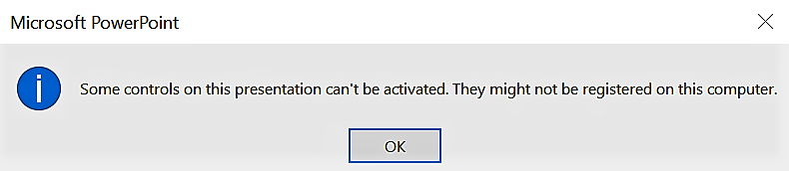

Steps to resolve the issue
Please note: you will need administrator permissions for this process.

- Open Notepad program
- Copy and paste everything on the following page into Notepad
- Save the file as flash.reg
- Exit out of Notepad
- Press the Windows key and type ‘flash.reg’.
  - Double click on the ‘flash.reg’ file to run the file
  - If an elevated permissions (UAC) dialog appears, provide the necessary credentials, or reach out to your IT administrator
  - Restart all Office applications

Windows Registry Editor Version 5.00
[HKEY_LOCAL_MACHINE\SOFTWARE\Microsoft\Office\16.0\Common\COM Compatibility]
[HKEY_LOCAL_MACHINE\SOFTWARE\Microsoft\Office\16.0\Common\COM Compatibility\{D27CDB6E-AE6D-11CF-96B8-444553540000}]
"Compatibility Flags"=dword:00000000
"ActivationFilterOverride"=dword:00000001
[HKEY_LOCAL_MACHINE\SOFTWARE\Microsoft\Office\16.0\Common\COM Compatibility\{D27CDB70-AE6D-11CF-96B8-444553540000}]
"ActivationFilterOverride"=dword:00000001
"Compatibility Flags"=dword:00000000
[HKEY_LOCAL_MACHINE\SOFTWARE\WOW6432Node\Microsoft\Office\16.0\Common\COM Compatibility]
[HKEY_LOCAL_MACHINE\SOFTWARE\WOW6432Node\Microsoft\Office\16.0\Common\COM Compatibility\{D27CDB6E-AE6D-11CF-96B8-444553540000}]
"Compatibility Flags"=dword:00000000
"ActivationFilterOverride"=dword:00000001
[HKEY_LOCAL_MACHINE\SOFTWARE\WOW6432Node\Microsoft\Office\16.0\Common\COM Compatibility\{D27CDB70-AE6D-11CF-96B8-444553540000}]
"Compatibility Flags"=dword:00000000
"ActivationFilterOverride"=dword:00000001

