- DNA controls the function of cells by controlling the production of proteins. Answer the following questions about proteins.

a) Explain how the structure of a protein is determined by the order of base pairs in a DNA molecule. Include the following terms: amino acids, triplet, sequence, base code.


………………………………………………………………………………………….…………
….…………………………………………………………………………………………………
………………………………………………………………………………………….…………
………………………………………………………………………………………….…………
….…………………………………………………………………………………………………
………………………………………………………………………………………….…………

b) Different proteins are made of different sequences of amino acids joined together to form polypeptide chains. Each protein consists of one or more polypeptide chains. The number and sequence of amino acids in a protein determine its shape and biological functions. Name two functions of proteins.

………………………………………………………………………………………….…………
….…………………………………………………………………………………………………
………………………………………………………………………………………….…………

c) Name two specific proteins.

………………………………………………………………………………………….…………
….…………………………………………………………………………………………………
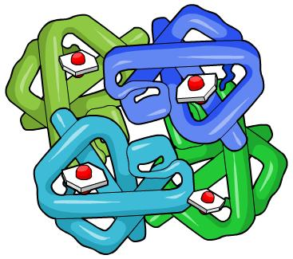
- Fill in the gaps in the table below to complete the process of protein synthesis.

Stages in the process | What happens
Stage 1 | A section of ………………… containing the gene unwinds and the two strands separate.
Stage 2 – ………………………........... | A molecule of RNA is produced, containing a copy of the genetic information.
Stage 3 – mRNA moves out of the nucleus | The new RNA molecule called ………………… RNA (mRNA) leaves the nucleus and enters the cytoplasm.
Stage 4 | The mRNA attaches to a ribosome in the cytoplasm.  The ribosome ……………...... the sequence of codons in  the mRNA.
Stage 5 – ……………………………… | As the mRNA passes through the ribosome, the correct amino acid is added to the growing chain by tRNA. Amino acids link up to form a polypeptide.
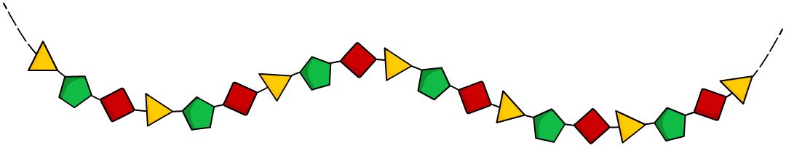  Stage 6 – Modification of the protein. | A completed polypeptide chain is released into the cytoplasm. Several ………………… combine to form a protein.

- Draw a diagram to show the process of transcription. Label your diagram using the following terms: molecule of RNA, exposed bases, DNA strands, nucleus.

